SF4 – Datalogger Interim Report
Rahul Sharma rs2288 & Owen Marlovits om399
Analogue Circuit Design
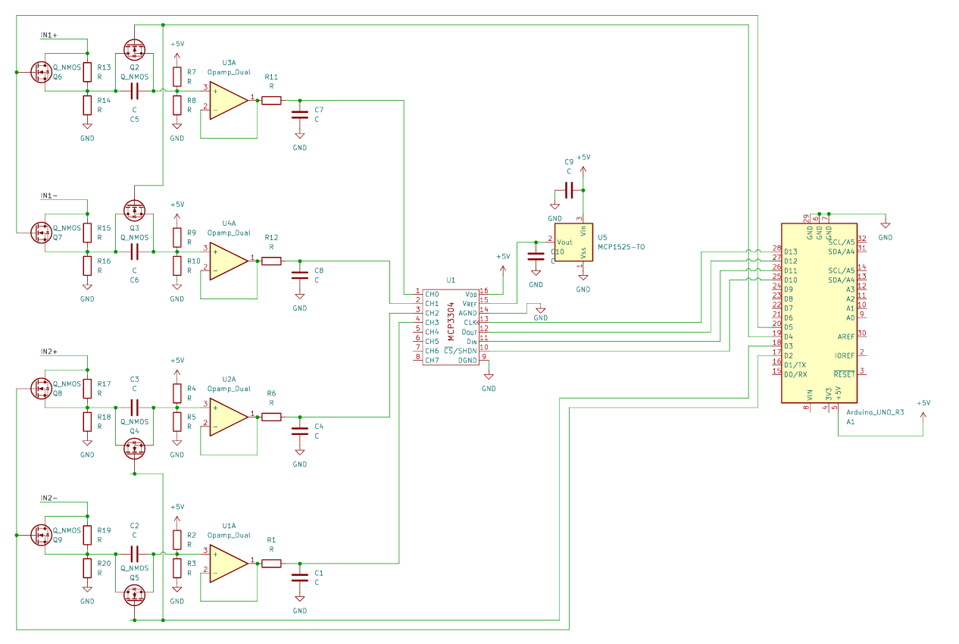
The analogue circuit design is as above, this does not include connections between the MCP3304 and the Arduino as KiCad does not have an Arduino Symbol in their Schematics although this is just two connections for the SPI communication.
Hardware Block Diagram
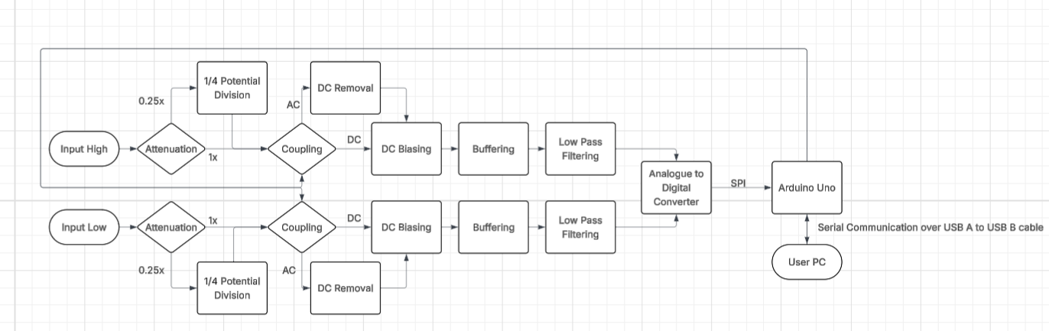
Firmware Block Diagram

Software Design

Parts List
Part Name | Number Required | Cost per unit | Total Cost
MCP1525 Voltage Regulator | 1 | 0.88 | 0.88
MCP6004-I/P Op Amp | 4 | 0.46 | 1.84
2N7000-D26z N Channel MOSFET | 8 | 0.14 | 1.12
MCP3304-BI/SL Analogue to Digital Converter | 1 | 5.11 | 5.11
FIT0291 IC Adapter Board | 1 | 0.84 | 0.84
CTM-30C Crocodile Clip | 4 | 0.42 | 1.68
 |  |  | Overall Cost: 11.47
We have not listed Passive components i.e. Resistors and Capacitors and this is only for the two channel configuration.
Division of Tasks

